# **Key Information**

| **Project title** | Healthcare Data Analysis |
| --- | --- |
| **Members** | Shiza Alam Khan (2022F-BCS-207)  Maimoona Shah Khan (2022F-BCS-241) |
| **Course** | Database SystemsCS-229L |
| **Instructor** | Sabeen Fatima |
| **Department** | Computer Science & It |
| **Section** | E |
| **Semester** | 4th |

# 

# **Objective**

To analyze healthcare data using SQL queries and PowerBi for visualization.

## **Tech stack**

SQL

Microsoft SQL Server Management Studio

PowerBi

## **About data**

We used synthetic data from Kaggle.com. We downloaded csv files of the data, converted them into Excel files and then imported all the tables in SQL. During this process we had to troubleshoot quite a few problems but we got the work done.

## **Problem statements**

Using SQL we answered the following questions by querying the data.

1. **Patient Demographics**
   1. **What is the age distribution of patients?**

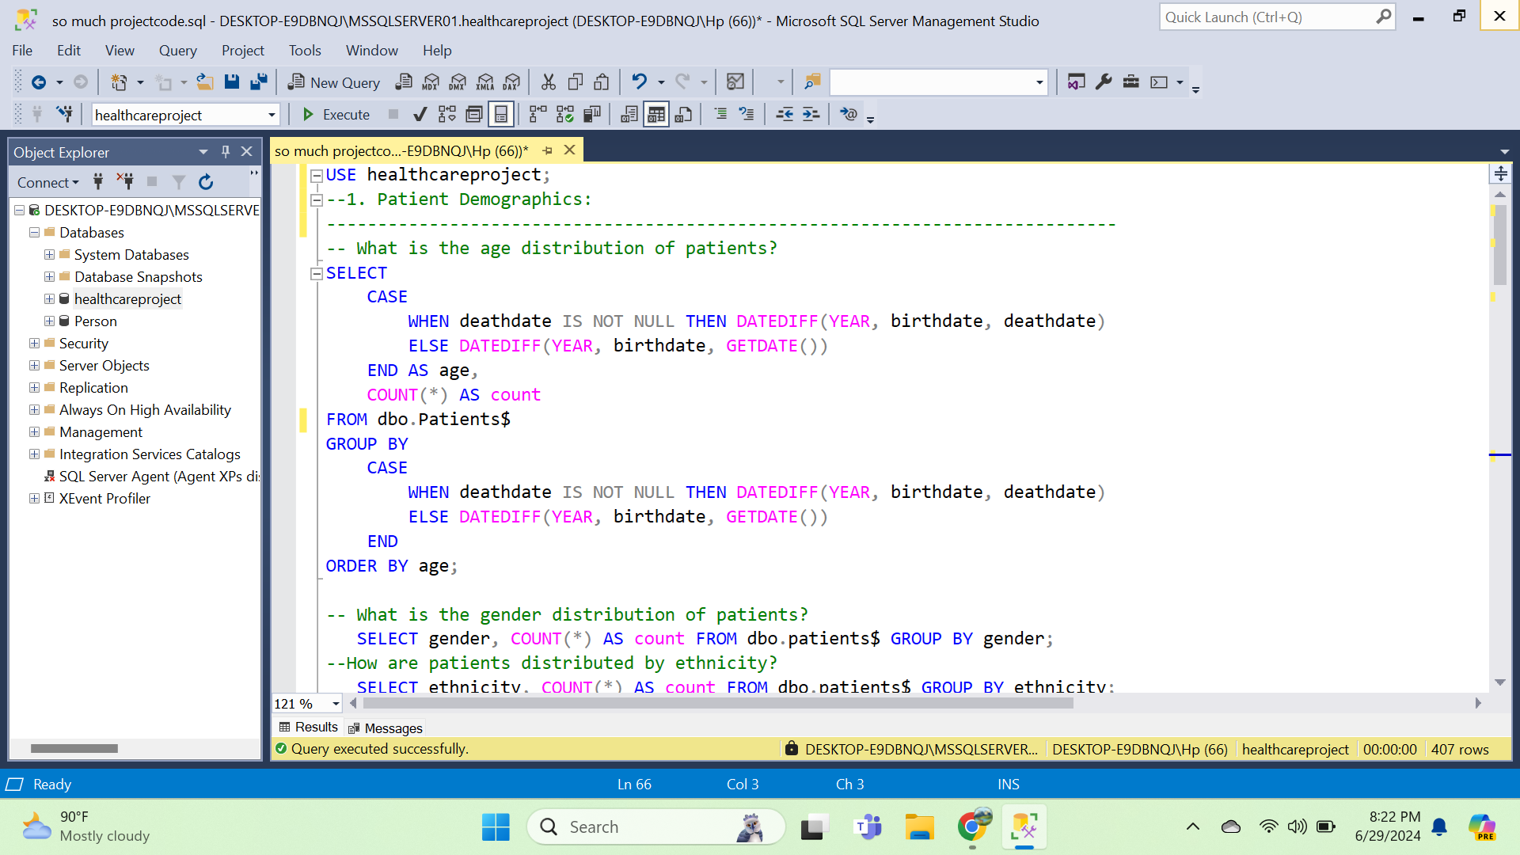

* 1. **What is the gender distribution of patients?**



* 1. **How are patients distributed by ethnicity?**

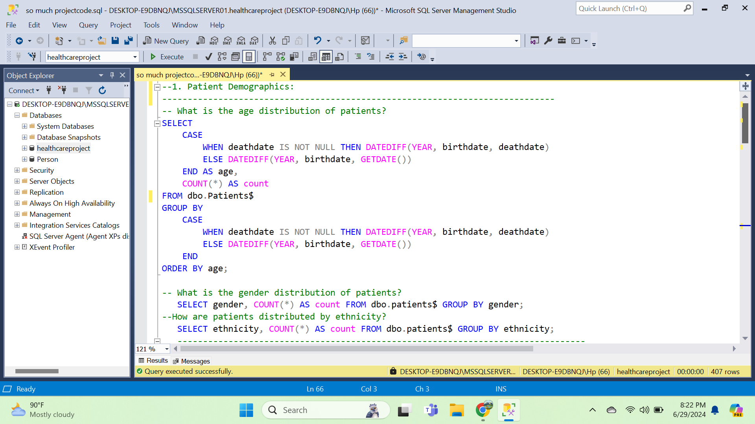

1. **Diagnosis**
   1. **What is the most common condition affecting patients ?**

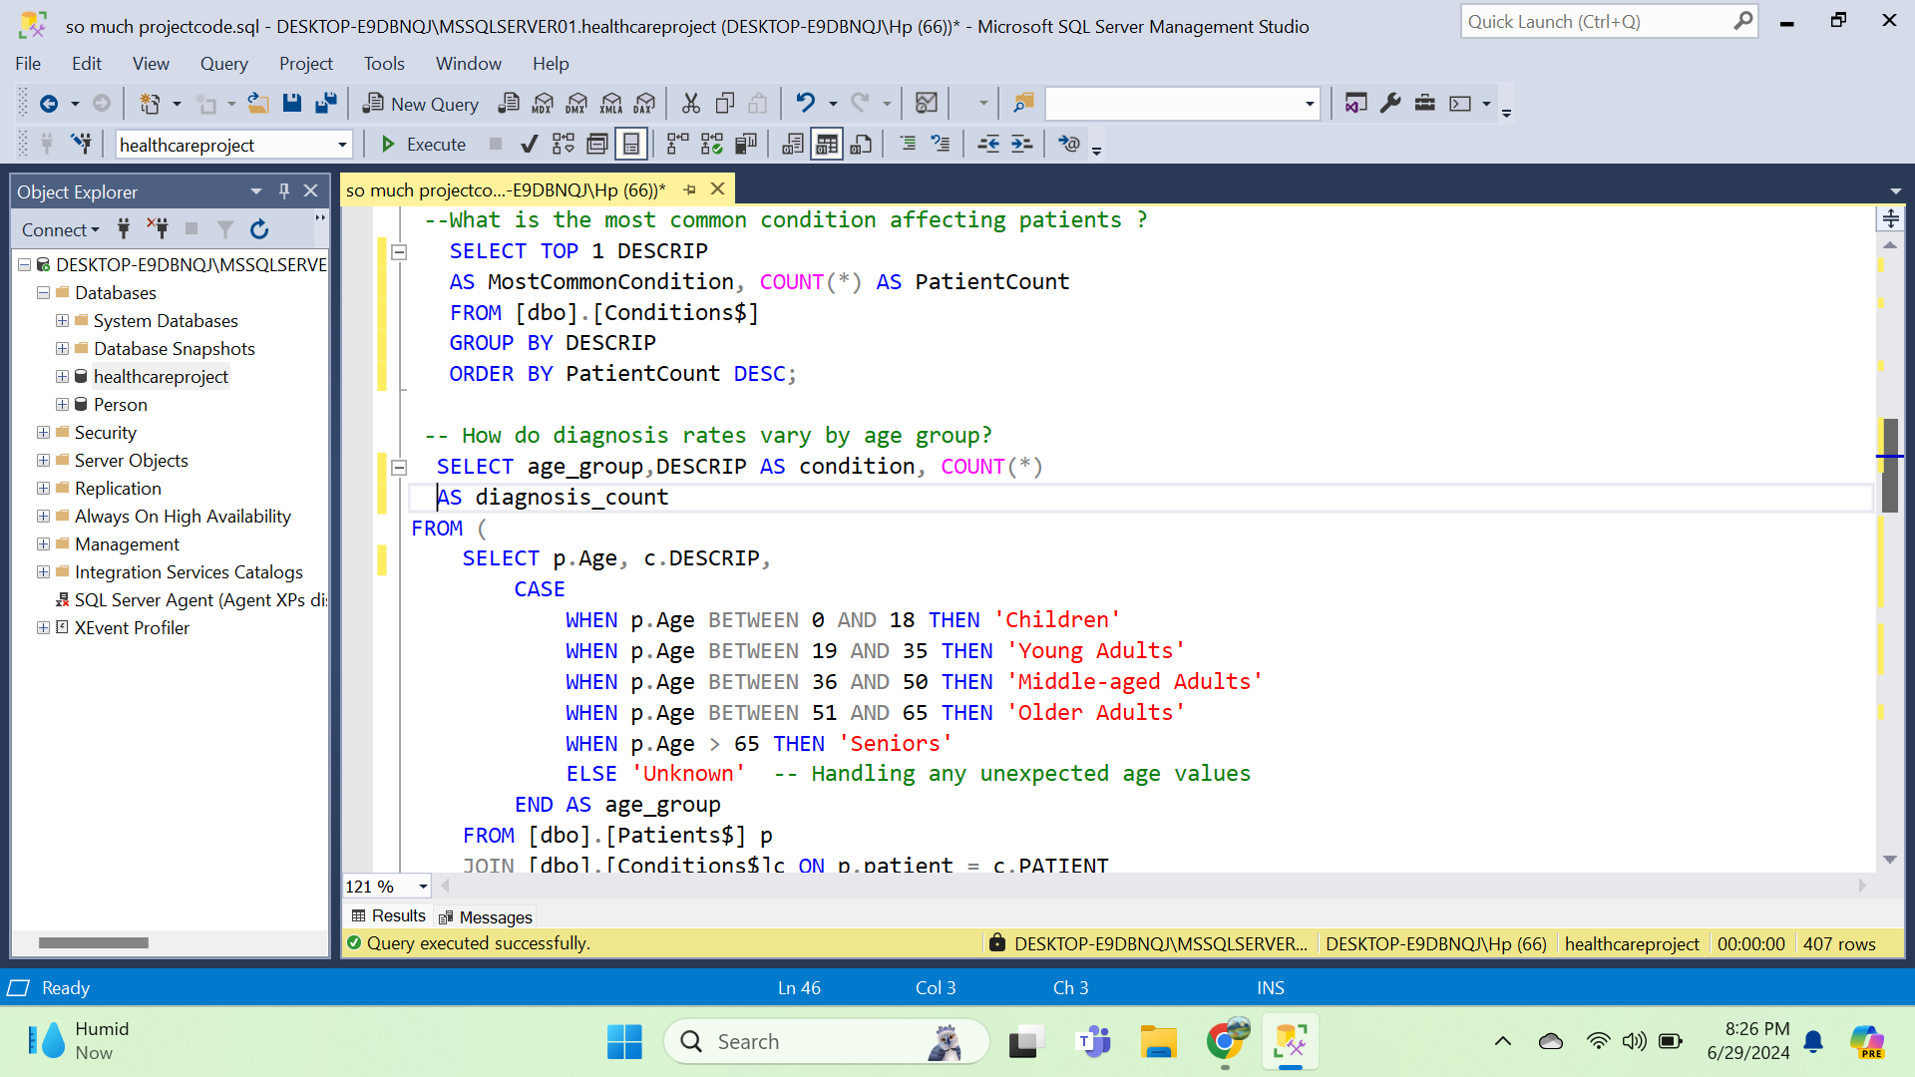

* 1. **How do diagnosis rates vary by age group?**

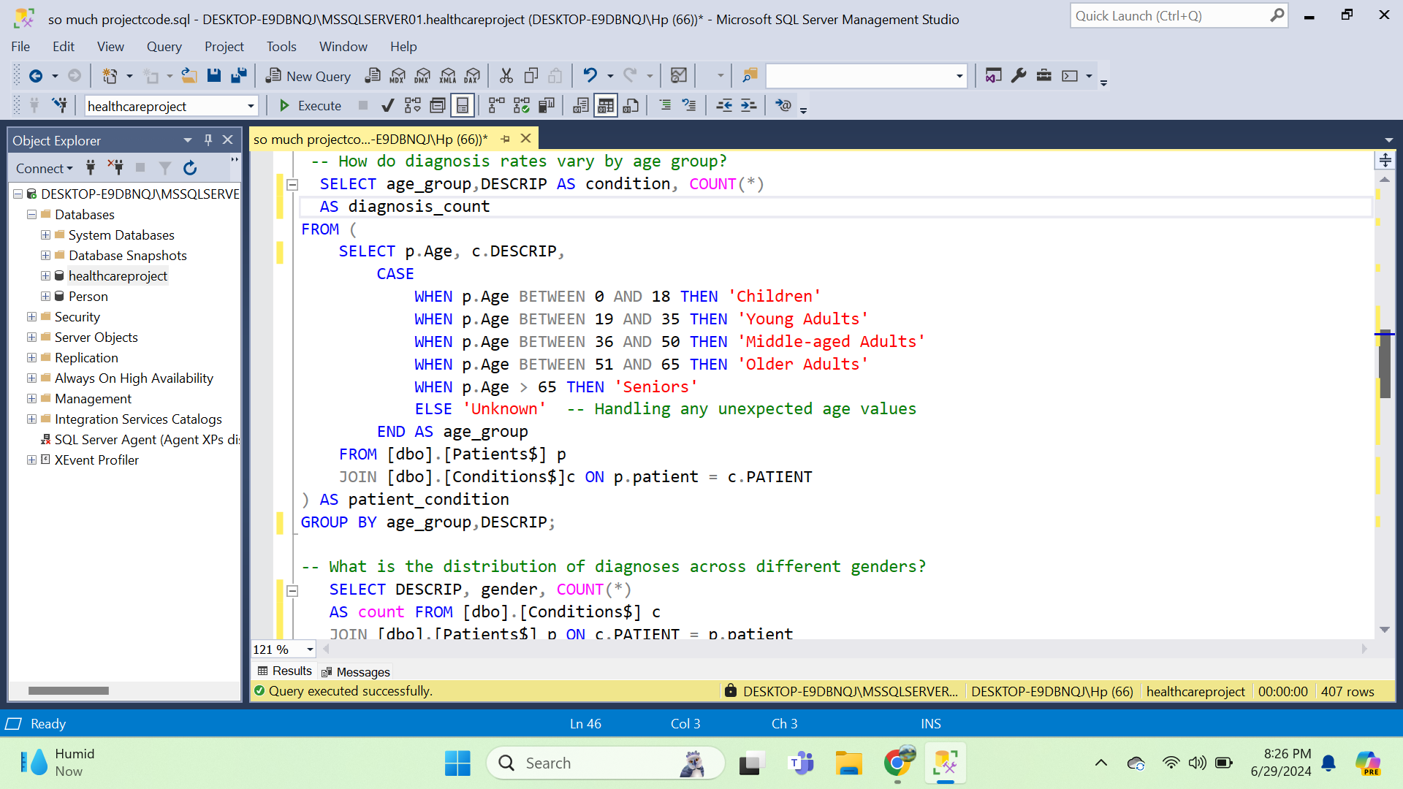

* 1. **What is the distribution of diagnoses across different genders?**

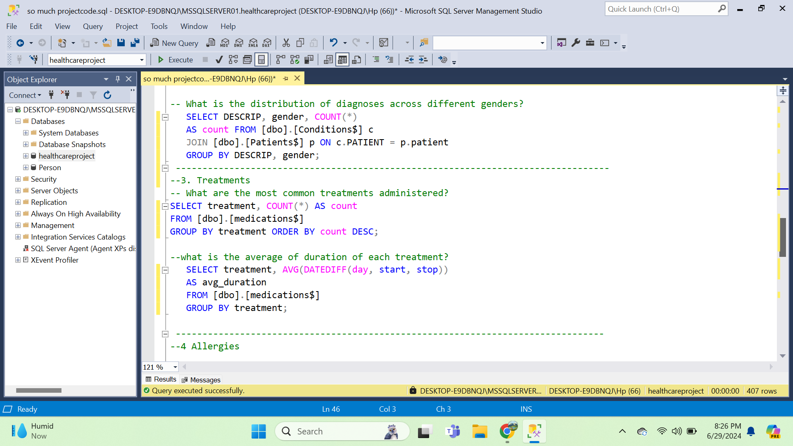

1. **Treatments**
   1. **What are the most common treatments administered?**



* 1. **What is the average duration of each treatment?**



1. **Allergies**
   1. **What is the number of occurrences for each allergy?**

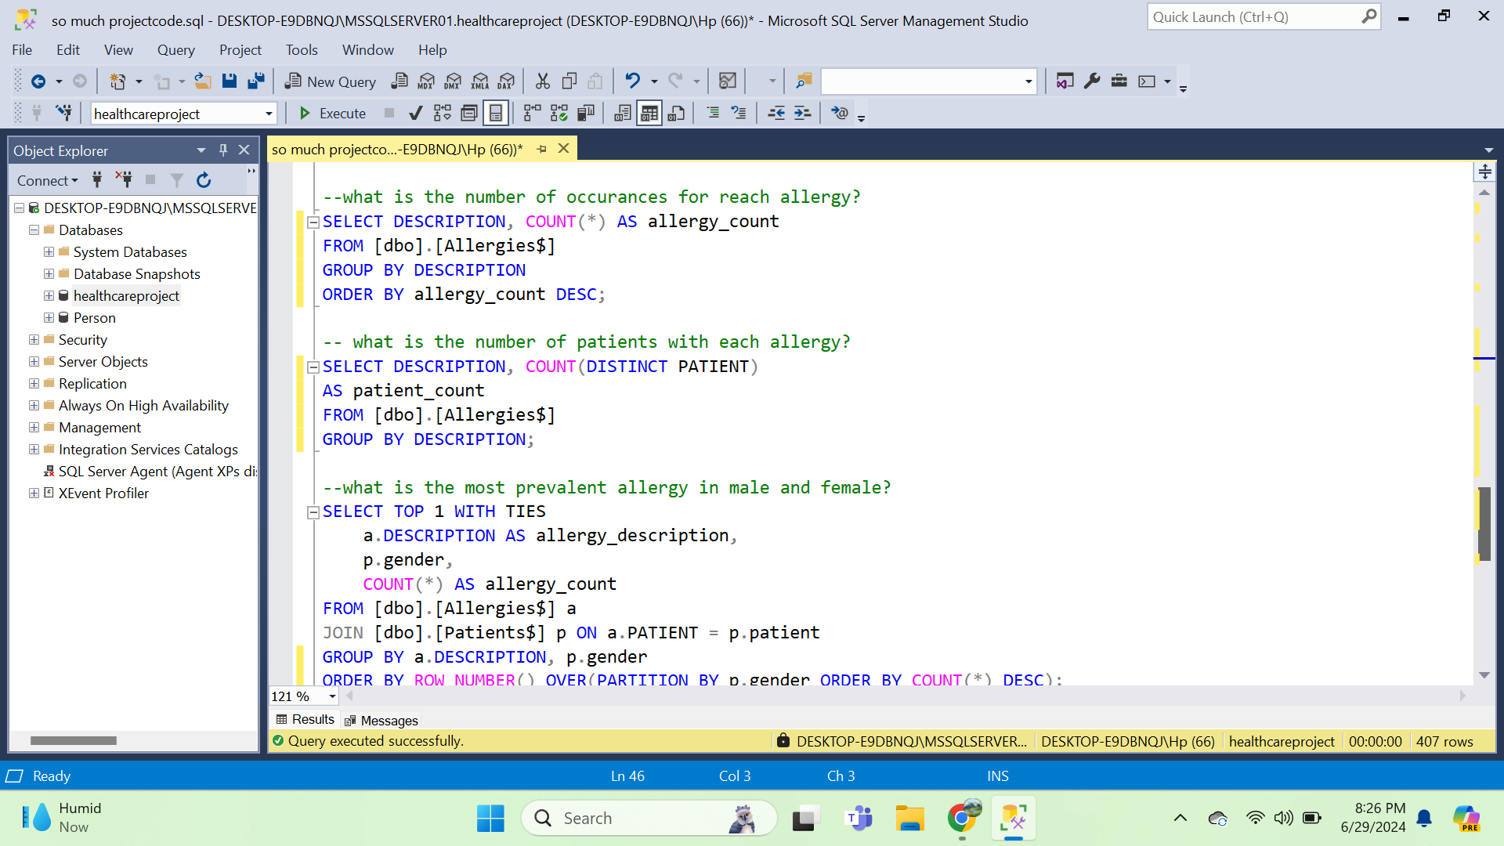

* 1. **What is the number of patients with each allergy?**



* 1. **What is the most prevalent allergy in male and female patients?**

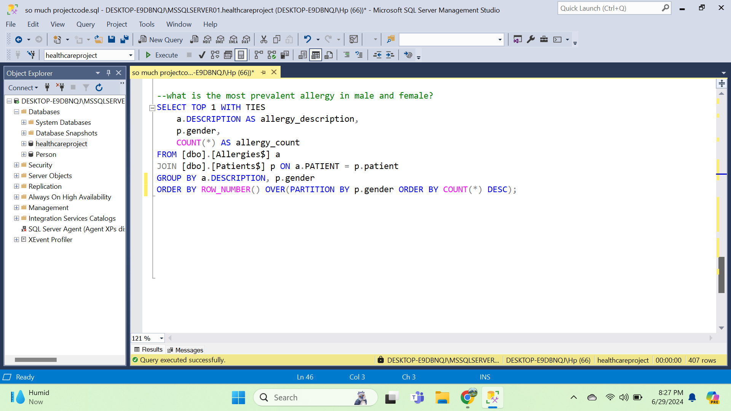

## **Visualization**

To visualize our insights gathered from SQL queries we used PowerBi and created interactive dashboard.

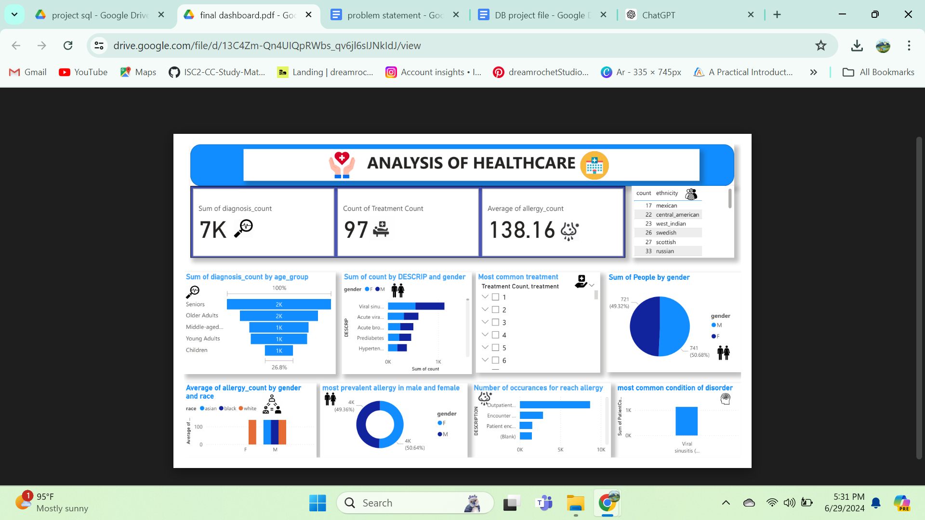

## **Conclusion**

This project gave us a chance to showcase our knowledge and learn a new skill along the way. We had a great chance to practice our SQL querying.